BYLAWS

PREAMBLE
The purpose of these bylaws is to provide guidance, organization and additional details beyond the Constitution of how Bethel Baptist Church will carry out our Core Values, and our Mission. It will define the roles, responsibilities, and structure of various teams and groups that are used within the church.

1.0 Organization
The following organization chart is a basic structure of the church.
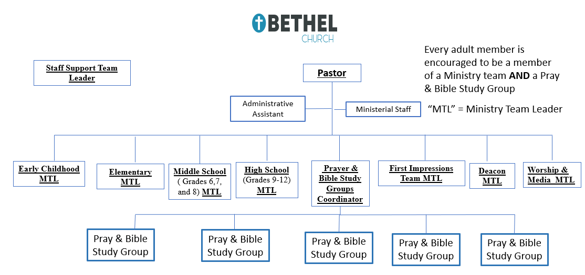
2.0 Individual Roles and Responsibilities
2.1 Pastor
2.1.1 Role of Pastor
- Study the Bible and pray so that he can lead the church in Bible centered preaching that comes from an overflow of what God is doing in his life
- Shepherd the church through pastoral care
- With the help of the Worship and Media Team, leads the church in worship
- Gives direction and oversight to the work of the Bethel Leadership Team
- Ensures an intentional leadership development process is in place for both current and future leaders
2.1.2 Selection of the Pastor
A. The Bethel Leadership Team as (defined in Section 1.2) has lead responsibility of establishing the process of selecting the Pastor
B. The process will meet the following requirements:
- The Bethel Leadership Team shall bring to the consideration of the church only one name at a time.
- Election shall be by ballot, an affirmative vote of three-fourths (75%) of those present being necessary for a choice.
- The pastor, thus elected, shall serve until the relationship is terminated by his request or the church's request.
2.1.3 Vacating of the Pastor
A. The pastor may relinquish the office as pastor by giving proper notice as outlined in the ???? Personnel Policies, Article I, Section D, Item 1 at the time of resignation.
B. The church may declare the office of pastor to be vacant. This process is initiated by the Bethel Leadership Team or by a written petition signed by not less than one-fourth of the Covenant Members (Covenant Members is defined in the Constitution). Such action shall take place at a special called business meeting as defined in Section ???? called for that purpose. The vote to declare the office vacant shall be by secret ballot; an affirmative vote of two-thirds of the members present being necessary to declare the office vacant. The termination shall be immediate and compensation shall be rendered according to Personnel Policy Article I, Section D, Item 3. ?????

2.2 Bethel Leadership Team
2.2.1 Members
A. Early Childhood Ministry Team Leader
B. Elementary Ministry Team Leader
C. Middle School Ministry Team Leader
D. High School Ministry Team Leader
E. Prayer & Bible Study Groups Coordinator
F. First Impressions Team Ministry Team Leader
G. Deacon Ministry Team Leader
H. Worship & Media Ministry Team Leader
I. Staff Support Team Leader
J. Administrative Assistant
K. Ministerial Staff
L. Communications Analysis
2.2.2 Qualifications – See each Team Leader in following sections
2.2.3 Election Process
    - Nominated by the current Bethel Leadership Team and voted on by the church
    - Needs 50% approval of members present to pass
2.2.4 Key Objectives
    - Meetings will have list of attendees, minutes and key decisions documented and available to all church members
    - Prepare the annual budget at the Team level and submit to the church for approval
    - Establish an annual plan of ministries, activities, and events that are centered around our mission
2.2.1.A. Ministry Team - Early Childhood
      - Purpose of the Team
        - Team consists of 12-15 people
        - Conduct and lead all ministry and discipleship activities done by Bethel for the Early Childhood age group (birth – Pre-5)
      - Duties of the Team
        - Establish a standard of “spiritual maturity/Bible knowledge” desired for children in that age group to reach prior to moving to the next age group
        - Have a process for children coming into the group for the first time who are new to the discipleship process to get them caught up to the level of “spiritual maturity/Bible knowledge” for their age
          - Includes age specific “new member training”
          - Differentiated instruction
          - Mentorship with one-on-one relationships
        - Have specific classes during the worship service (10:00 – 11:00 A.M.) geared for their minds and attention spans
      - Key Objectives
        - Teams plan and conduct their ministry
        - Teams do not plan activities and events for other teams
        - Events and activities that involve more than one ministry team must be coordinated by a leader from one of those teams but all teams involved should in in agreement and working together
      - Ministry Team Leader
        - Responsibilities
        - Qualifications
        - Terms of Service
        - Election Process
2.2.1.A.1. Bethel Learning Center
      - Purpose
      - Duties
      - Key Objectives
2.2.1.B. Ministry Team - Elementary
      - Purpose of the Team
        - Team consists of 12-15 people
        - Conduct and lead all ministry and discipleship activities done by Bethel for the Early Childhood age group (Kindergarten – Grade 5)
      - Duties of the Team
        - Establish a standard of “spiritual maturity/Bible knowledge” desired for children in that age group to reach prior to moving to the next age group
        - Have a process for children coming into the group for the first time who are new to the discipleship process to get them caught up to the level of “spiritual maturity/Bible knowledge” for their age
          - Includes age specific “new member training”
          - Differentiated instruction
          - Mentorship with one-on-one relationships
        - Have specific classes during the worship service (10:00 – 11:00 A.M.) geared for their minds and attention spans
      - Key Objectives
        - Teams plan and conduct their ministry
        - Teams do not plan activities and events for other teams
        - Events and activities that involve more than one ministry team must be coordinated by a leader from one of those teams but all teams involved should in in agreement and working together
      - Ministry Team Leader
        - Responsibilities
        - Qualifications
        - Terms of Service
        - Election Process
2.2.1.C. Ministry Team - Middle School
      - Purpose of the Team
        - Team consists of 12-15 people
        - Conduct and lead all ministry and discipleship activities done by Bethel for the Early Childhood age group (Grades 6, 7 and 8)
      - Duties of the Team
        - Establish a standard of “spiritual maturity/Bible knowledge” desired for children in that age group to reach prior to moving to the next age group
        - Conduct discipleship training at a time that best works for those in the age group
        - Have a mentoring process to encourage students to team with adults to get them involved in serving so that after high school they join a ministry team
        - Have a process for youth coming into the group for the first time who are new to the discipleship process to get them caught up to the level of “spiritual maturity/Bible knowledge” for their age
          - Includes age specific “new member training”
          - Differentiated instruction
          - Mentorship with one-on-one relationships
      - Key Objectives
        - Teams plan and conduct their ministry
        - Teams do not plan activities and events for other teams
        - Events and activities that involve more than one ministry team must be coordinated by a leader from one of those teams but all teams involved should in in agreement and working together
        - Start the discovery process of spiritual gifts and small service projects
        - Allow youth to witness and explore all ministry teams to get a glimpse as to what they might want to do in their future
      - Ministry Team Leader
        - Responsibilities
        - Qualifications
        - Terms of Service
        - Election Process
2.2.1.D. Ministry Team – High School
      - Purpose of the Team
        - Team consists of 12-15 people
        - Conduct and lead all ministry and discipleship activities done by Bethel for the Early Childhood age group (Grades 9, 10, 11, and 12)
      - Duties of the Team
        - Establish a standard of “spiritual maturity/Bible knowledge” desired for children in that age group to reach prior to moving to the next age group
        - Conduct discipleship training at a time that best works for those in the age group
        - Have a mentoring process to encourage students to team with adults to get them involved in serving so that after high school they join a ministry team
        - Have a process for youth coming into the group for the first time who are new to the discipleship process to get them caught up to the level of “spiritual maturity/Bible knowledge” for their age
          - Includes age specific “new member training”
          - Differentiated instruction
          - Mentorship with one-on-one relationships
      - Key Objectives
        - Teams plan and conduct their ministry
        - Teams do not plan activities and events for other teams
        - Events and activities that involve more than one ministry team must be coordinated by a leader from one of those teams but all teams involved should in in agreement and working together
        - Help youth discover their spiritual gifts. Then enable and train them to be able to enter into a ministry team upon graduation of High School.
      - Ministry Team Leader
        - Responsibilities
        - Qualifications
        - Terms of Service
        - Election Process
2.2.1.E. Prayer and Bible Study Teams Coordinator
      - Responsibilities
      - Qualifications
      - Election Process
      - Term of Service
      - Key Objectives
E.1 Prayer and Bible Study Group Leaders
      - Purpose of the Team
      - Duties of the Team
      - Key Objectives
      - Responsibilities of the leader
      - Qualifications of the leader
2.2.1.F. Ministry Team - First Impressions Team
      - Purpose of the Team
        - The Worship Pastor oversees this ministry team
        - Ensure all grounds and facilities are in proper condition and functioning to create a positive impression for all members and guests
      - Duties of the Team
        - Conduct all activities to enable all members and guests to have a positive experience for regular and special worship service
          - Welcoming
          - Security
          - Ushering
        - Greeting and leading guests to the proper places
          - Early Childhood and Elementary ministries to the proper building
          - Seating guests in the Sanctuary
        - All signage throughout all facilities are place before each worship service
        - Opening and closing of all facilities after regular scheduled services
        - Develop a longer-term plan to maintain and upgrade facilities as needed to accomplish the long-range plans of the Bethel Leadership Team
      - Key Objectives
        - First Impressions Team members are sensitive to how others experience our church and strive to look through their eyes
        - Work closely with the Worship and Media Team to implement the recommendations of the PAW Team
      - Ministry Team Leader
        - Responsibilities
        - Qualifications
        - Terms of Service
        - Election Process
2.2.1.G. Ministry Team - Deacon Team
      - Purpose of the Team
        - Consists of 5-7 people
        - Nurture church members who are not in Prayer and Bible Study Groups striving to get them connected to one of the teams
        - Pray for and support the Pastor and the Bethel Leadership Team
      - Duties of the Team
        - Pay special attention to the sick, the widows, the widowers, the needy, the distressed, and the inactive members
        - Support the Lord’s Supper and Baptism ordinances
        - Support church members during bereavement
      - Key Objectives
        - The deacon ministry would not be responsible for caring for people who are in a Prayer and Bible Study Group
        - Each Prayer and Bible Study Group is responsible for nurturing and caring for the members of their team
      - Ministry Team Leader
        - Responsibilities
        - Qualifications
        - Terms of Service
        - Election Process
2.2.1.H. Ministry Team – Worship and Media Team
      - Purpose of the Team
        - The Worship Pastor oversees this ministry team
        - Lead the church to be Passionate About Worship
      - Duties of the Team
        - Plan and lead all church worship services
        - Plan and lead all social media activities including the website, Facebook and all other media platforms
        - Ensure the church networks and information technology equipment, software, including infrastructure, is maintained throughout the church
      - Key Objectives
        - Work closely with the First Impressions Team to implement the recommendations of the PAW Team and keep cohesive graphic design/brand among brochures, booklets, and any other documents related to the First Impressions Team
      - Ministry Team Leader
        - Responsibilities
        - Qualifications
        - Terms of Service
        - Election Process
2.2.1.I. Ministry Team – Staff Support Team
      - Purpose of the Team
        - Team consists of 4-6 people (Two of which must be the Church Treasurer and assistant Church Treasurer)
        - Audit the financial records of the church to assure they were expended according to the budget established by the Bethel Leadership Team and approved by the church
      - Duties of the Team
        - Conduct an annual performance evaluation of the pastor
        - Establish the salary for the pastor based around that annual performance evaluation
        - Approve the performance evaluations of other paid staff members performed by the Pastor
        - Serve as the legal representatives of the church
        - Document all church conferences
        - Have at least four meetings a year where they evaluate the financials of the church and determine the standing of the current budget. A report must be published to the church body about their findings as well as their minutes from their meeting given to the Communication Analysis (???)
      - Key Objectives
      - Ministry Team Leader
        - Responsibilities
        - Qualifications
        - Terms of Service
        - Election Process
2.2.1.J. Administrative Assistant
      - Responsibilities
      - Qualifications
      - Election Process
      - Term of Service
      - Key Objectives
2.2.1.K. Ministerial Staff
      - Responsibilities
        - Reports to the pastor
        - Directs the ministry through the corresponding leaders in that ministry team
      - Qualifications
      - Election Process
        - The Bethel Leadership Team as (defined in Section 1.2) has lead responsibility of establishing the process of selecting the Pastor
        - The process will meet the following requirements:
      - The Bethel Leadership Team shall bring to the consideration of the church only one name at a time.
      - Election shall be by ballot, an affirmative vote of three-fourths (75%) of those present being necessary for a choice.
      - The staff member, thus elected, shall serve until the relationship is terminated by his request or the church's request.
      - Term of Service
        - Holds the position until the staff member vacates the position.
          - The pastor may relinquish the office as pastor by giving proper notice as outlined in the ???? Personnel Policies, Article I, Section D, Item 1 at the time of resignation.
          - The church may declare the office of pastor to be vacant. This process is initiated by the Bethel Leadership Team or by a written petition signed by not less than one-fourth of the Covenant Members (Covenant Members is defined in the Constitution). Such action shall take place at a special called business meeting as defined in Section ???? called for that purpose. The vote to declare the office vacant shall be by secret ballot; an affirmative vote of two-thirds of the members present being necessary to declare the office vacant. The termination shall be immediate and compensation shall be rendered according to Personnel Policy Article I, Section D, Item 3. ?????
      - Key Objectives
2.2.1.L. Communications Analysis
      - Responsibilities
      - Qualifications
      - Election Process
      - Term of Service
      - Key Objectives

3.0 Business Meetings
moderator in all business meetings in keeping with Robert's Rules of Order Revised by Henry M. Robert, Copyright 1915.
Moderator
Regular Business Meetings
Special Called Business Meetings
4.0 Church Discipline

